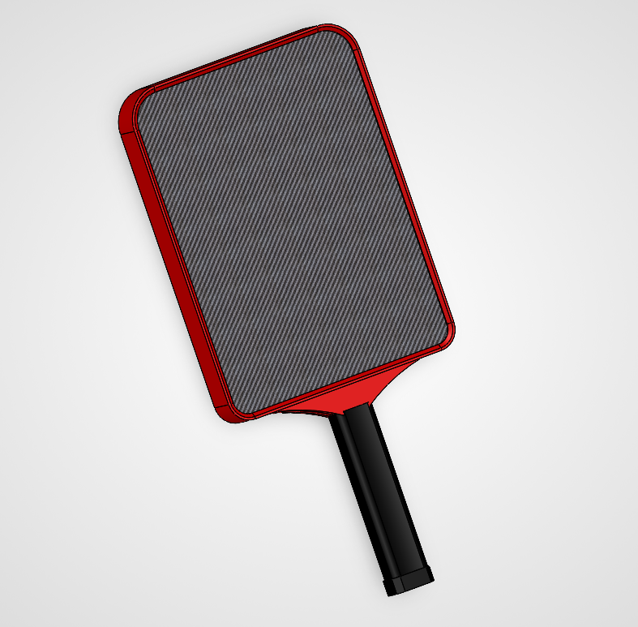

The design of my pickleball paddle was based on maximizing dwell time on the ball to allow for maximal spin. The size of the paddle was based on USA pickleball regulations. Aesthetically, the goal was an angular, framed paddle with a clean carbon face.
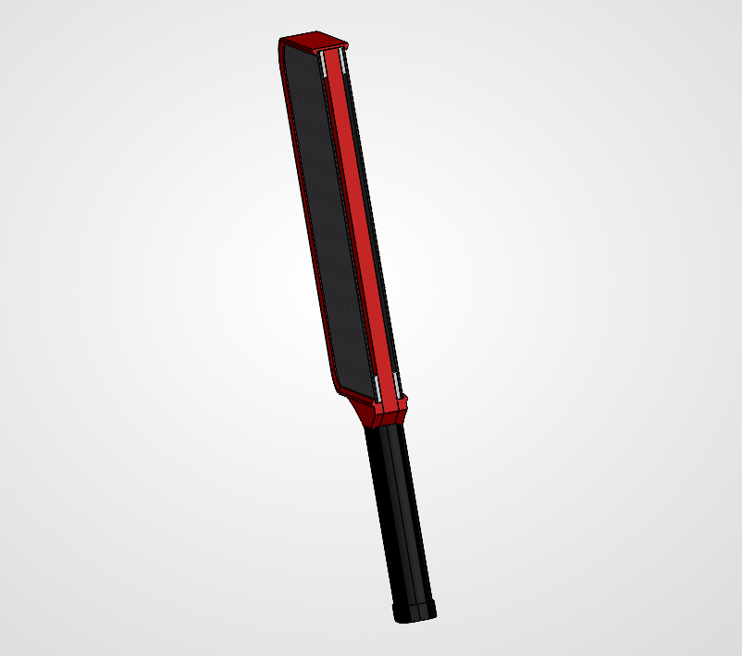
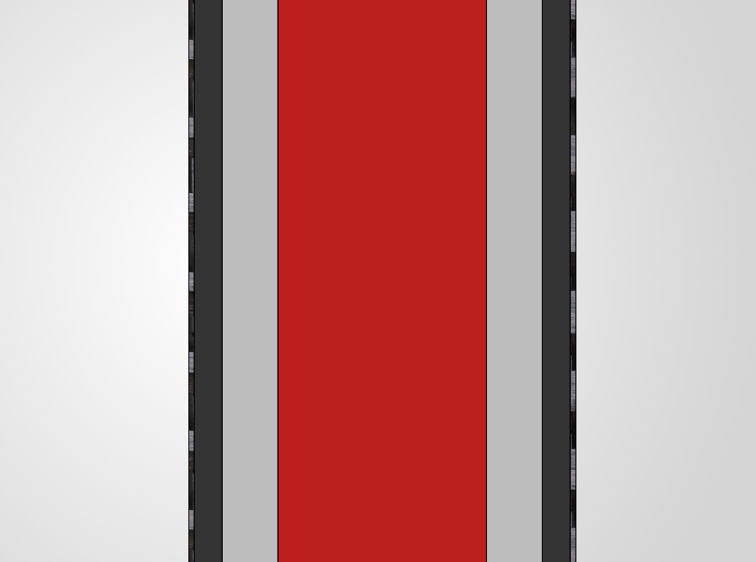
The paddle construction is a four-layer structure. The core of the paddle is 3D-printed PLA with 10% infill in a repeating hexagonal pattern. The next layer, working outward from the core, is an air-gap ring designed to allow the paddle face to bend inward, creating a trampoline effect that increases dwell time on the face of the paddle. The next layer is a 1 mm TPU backing sheet for the carbon face to help with the trampoline effect. The final outermost layer is the .3 mm 3k Carbon veneer sheet.

Conclusion on Project
The pedal design was 3D-printed and assembled. All parts fit together well, and the overall design came together as I imagined it. The raw carbon fiber top sheet, combined with the paddle's red frame, gave the look I was looking for. However, the pedal's performance was disappointing.
The paddle design was intended to maximize dwell time and give the ball a trampoline effect, allowing for maximal power and spin. The air gap design was intended to allow the ball to sink into the face and give a trampoline effect. However, the air gap design did not work. The raw carbon fiber sheet with the TPU backing did not provide enough spring to pop the ball off effectively. The air gap design produced a somewhat muted effect and made the paddle extremely loud. The PLA core, even with a 10% infill, did not give the pop I was looking for and still seemed too stiff and not elastic enough.
The biggest success I had in this project was the paddles' aesthetics. Aesthetically, I was hoping for a paddle with a clean carbon face sheet and a boxier look. I felt that the finished product has a high-end look to it, and the clean carbon face amplifies this effect.

Changes to version 2
If I were to keep iterating on this project and make a version 2, I would remove the air gap design and replace the core with a TPU lattice structure. Aesthetically, I would not change the paddle; I really like how it looks. The carbon face sheet, however, could be replaced with a different carbon, possibly a peel ply type that provides more grip, since the current carbon sheet is not very grippy.

